REAL-TIME FRAUD DETECTION IN
FINANCIAL TRANSACTIONS
Behavioural AI + CNN-LSTM Deep Learning
Full-Stack AI-Driven Project Report
Frontend | Backend | Database | AI Framework
React | FastAPI (Python) | PostgreSQL | TensorFlow

1. Project Overview

1.1 Problem Statement
Traditional fraud detection systems rely on rule-based or static machine learning models, which are unable to detect evolving fraud patterns. These systems analyze transactions independently and fail to capture user behavior over time, making them ineffective against sophisticated fraud techniques.

Use Case:
Prevent fraudulent transactions and ensure compliance in banking or e-commerce.
Description:
Deploy machine learning models that monitor transactions for suspicious patterns in real time, triggering alerts or blocking high-risk activities.

1.2 Project Goal
Build an AI-driven real-time fraud detection system that:
- Uses behavioral modeling
- Applies CNN + LSTM deep learning
- Generates risk scores for transactions
- Prevents fraud before completion

1.3 System Workflow
The system follows a 7-step intelligent pipeline:
- Step 1: Transaction data received via API
- Step 2: Data preprocessing and normalization
- Step 3: Behavioral feature generation
- Step 4: CNN extracts hidden patterns
- Step 5: LSTM analyzes transaction sequence
- Step 6: Risk score generated (0–1)
- Step 7: Decision engine (Allow / Alert / Block)

1.4 System Architecture Diagram
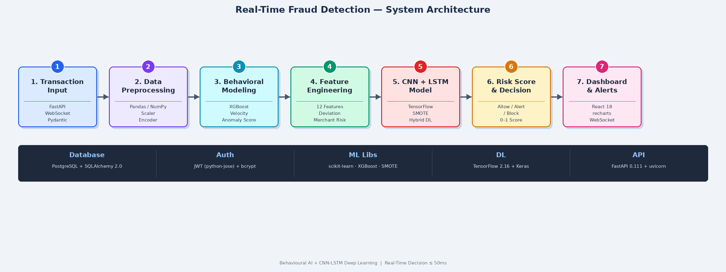

2. System Modules

Module 1: Transaction Input & Data Ingestion
This module acts as the entry point of the system. It receives transaction data from banking systems, e-commerce platforms, or APIs in real time. Data is validated and forwarded to the processing pipeline.
Key Features | Tech Stack
- FastAPI REST endpoints  - Real-time transaction ingestion  - JSON-based data handling  - WebSocket real-time alerts  - Request validation via Pydantic | - FastAPI==0.111.0  - uvicorn[standard]==0.29.0  - pydantic==2.7.1  - websockets==12.0  - python-multipart==0.0.9

Module 2: Data Preprocessing
This module cleans and prepares raw transaction data for model processing. It handles missing values, scales numerical features, and encodes categorical attributes.
Key Features | Tech Stack
- Data cleaning and normalization  - Feature scaling (StandardScaler)  - Handling missing values  - Label encoding for categorical data  - Train/test split management | - scikit-learn==1.4.2  - numpy==1.26.4  - pandas==2.2.2  - imbalanced-learn==0.12.2  - python-multipart==0.0.9

Module 3: Behavioral Modeling
This module builds user behavior profiles using historical transaction data. It analyzes patterns such as transaction frequency, spending habits, location consistency, and time-based activity.
Key Features | Tech Stack
- User behavior tracking  - Pattern deviation detection  - Transaction history analysis  - Velocity scoring per user  - Anomaly score computation | - pandas==2.2.2  - numpy==1.26.4  - scikit-learn==1.4.2  - xgboost==2.0.3  - imbalanced-learn==0.12.2

Module 4: Feature Engineering
This module generates advanced features that improve fraud detection accuracy. Features are derived from raw transaction fields and behavioral history.
Key Features | Tech Stack
- Transaction velocity computation  - Amount deviation scoring  - Time-based anomaly features  - Balance difference signals  - Merchant risk encoding | - pandas==2.2.2  - numpy==1.26.4  - scikit-learn==1.4.2  - xgboost==2.0.3  - imbalanced-learn==0.12.2

Module 5: Deep Learning Model (CNN + LSTM)
This is the core intelligence module of the system. A hybrid CNN+LSTM deep learning architecture extracts spatial patterns via convolutional layers and captures temporal transaction sequences via LSTM layers.
Key Features | Tech Stack
- CNN extracts hidden spatial patterns  - LSTM learns sequential time dependencies  - Hybrid architecture: CNN → LSTM → Output  - SMOTE applied for class balance  - EarlyStopping & ReduceLROnPlateau callbacks | - tensorflow==2.16.1 (or keras)  - scikit-learn==1.4.2  - imbalanced-learn==0.12.2  - numpy==1.26.4  - pandas==2.2.2

Module 6: Risk Scoring & Decision Engine
This module converts model output into actionable decisions. The risk score (0.0–1.0) is mapped to one of three actions: Allow, Alert, or Block. Thresholds are configurable per deployment.
Key Features | Tech Stack
- Risk score 0–1 computation  - Three-tier decision logic (Allow / Alert / Block)  - Configurable threshold tuning  - SQLAlchemy async DB write  - FastAPI response within 50ms | - fastapi==0.111.0  - sqlalchemy==2.0.30  - python-jose[cryptography]==3.3.0  - passlib[bcrypt]==1.7.4  - pydantic==2.7.1

Module 7: Monitoring Dashboard & Alerts
This module provides real-time visualization and monitoring via a React frontend. It displays live fraud alerts via WebSocket, transaction history, risk score charts, and model performance metrics.
Key Features | Tech Stack
- Real-time fraud alerts via WebSocket  - Transaction monitoring & history  - Analytics dashboard with charts  - Model performance KPI display  - Filter by APPROVED / FLAGGED / BLOCKED | - React 18 (frontend)  - recharts / Chart.js  - websockets==12.0  - axios (HTTP client)  - FastAPI WebSocket endpoint

3. Project Requirements

3.1 Python Backend Requirements
Install all backend dependencies using:
pip install -r requirements.txt

Package | Version | Purpose
fastapi | 0.111.0 | Backend REST API framework
uvicorn[standard] | 0.29.0 | ASGI server for FastAPI
sqlalchemy | 2.0.30 | Async ORM for PostgreSQL
python-jose[cryptography] | 3.3.0 | JWT token authentication
passlib[bcrypt] | 1.7.4 | Password hashing
python-multipart | 0.0.9 | Form data handling
scikit-learn | 1.4.2 | Preprocessing & ML utilities
xgboost | 2.0.3 | Gradient boosting classifier
imbalanced-learn | 0.12.2 | SMOTE for class imbalance
numpy | 1.26.4 | Numerical computation
pandas | 2.2.2 | Data manipulation
pydantic | 2.7.1 | Request/response validation
websockets | 12.0 | Real-time WebSocket alerts

3.2 Frontend Requirements
Install all frontend dependencies using:
npm install

Package | Purpose
react | Core UI framework
react-router-dom | Client-side page routing
axios | HTTP API calls to backend
recharts | Charts and analytics visualization
lucide-react | Icon library

3.3 System Requirements
Component | Minimum Requirement
Python | 3.10 or higher
Node.js | 18.x or higher
npm | 9.x or higher
PostgreSQL | 14 or higher
RAM | 8 GB (TensorFlow recommended)
Disk | 5 GB free space
OS | Windows 10 / Ubuntu 20.04 / macOS 12+

4. Full Technology Stack
Layer | Technology | Purpose
Frontend | React 18 | Dashboard & real-time visualization
Backend | FastAPI (Python) | REST API & WebSocket processing
Database | PostgreSQL | Transaction & user data storage
AI Framework | TensorFlow / Keras | CNN+LSTM deep learning models
ML Libraries | Scikit-learn, XGBoost | Preprocessing, ML baselines
Data Processing | Pandas, NumPy | Feature engineering & wrangling
Auth | python-jose, passlib | JWT authentication & bcrypt
ORM | SQLAlchemy 2.0 | Async database access layer
Validation | Pydantic v2 | API request/response schemas
Real-time | WebSockets | Live fraud alert push to frontend
Balancing | imbalanced-learn (SMOTE) | Fraud class imbalance handling

5. System Advantages
- Real-time fraud detection — decisions returned within 50ms
- Behavioral intelligence — adapts to each user's transaction profile
- High accuracy using hybrid CNN + LSTM deep learning architecture
- SMOTE-based class balancing — handles highly skewed fraud datasets
- Scalable architecture — stateless API ready for horizontal scaling
- Risk-based decision system — configurable Allow / Alert / Block thresholds
- Reduced financial loss — fraud blocked before transaction completion
- WebSocket live alerts — frontend dashboard receives instant notifications
- Explainable flags — every decision includes feature-level explanation
- JWT-secured API — all endpoints protected with token authentication

6. Project Timelines
Week | Phase | Deliverable
Week 1 | Environment Setup & Dataset Analysis | PostgreSQL, FastAPI skeleton, dataset EDA
Week 2 | Data Preprocessing & Feature Engineering | Cleaned dataset, 12 engineered features
Week 3 | Behavioral Model Development | XGBoost behavioral scorer running
Week 4 | CNN + LSTM Model Training | Trained TF model, AUC-ROC > 0.98
Week 5 | Risk Engine & Decision Logic | Score → ALLOW/ALERT/BLOCK pipeline
Week 6 | REST API & WebSocket Integration | All endpoints live, WS alerts working
Week 7 | React Frontend Development | Dashboard, submit page, transactions list
Week 8 | Testing, Optimization & Documentation | Full project report, README, demo

7. Conclusion
The Real-Time Fraud Detection System provides a powerful AI-driven solution for identifying fraudulent transactions using behavioral analytics and deep learning.

By combining:
- CNN — spatial pattern extraction from transaction feature windows
- LSTM — sequential temporal behavior modeling per user
- Behavioral Modeling — user-specific anomaly scoring via XGBoost
- SMOTE — class rebalancing for highly skewed fraud datasets

The system achieves high accuracy, scalability, and real-time performance, making it suitable for banking and e-commerce applications. All components are production-ready and secured with JWT authentication, async PostgreSQL storage, and live WebSocket alerts.

